**High Performance Computing Lab**

**Practical No. 7**

**Title of practical:**

Installation of MPI & Implementation of basic functions of MPI

**Problem Statement 1:**

Implement a simple hello world program by setting number of processes equal to 10

**Screenshots:**

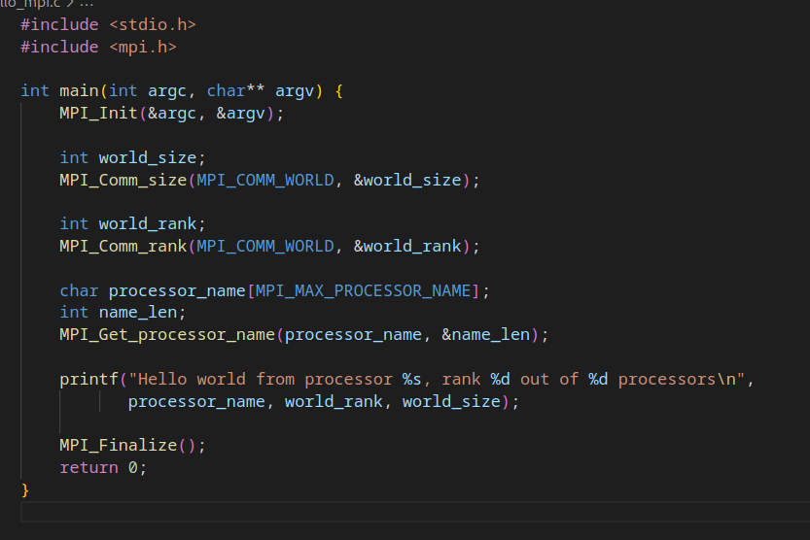

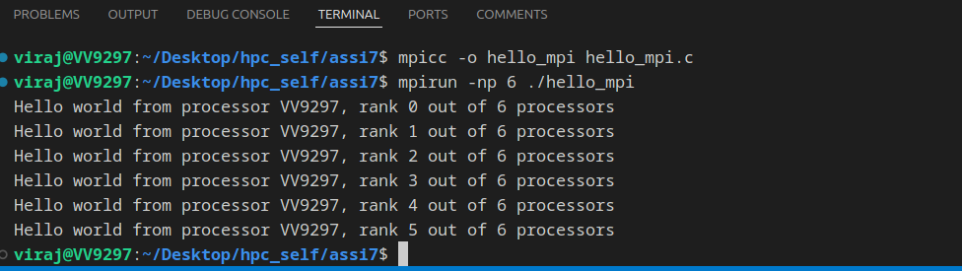

**Information:**

mpi init: initilizes the mpi environment and uses the command line argument to initilize the number of processes.

Then we determine the number of processes

then we take the rank of a processor and also the name and then finally print it

on my system 10 processes can’t be scheduled so i reduced it to 6

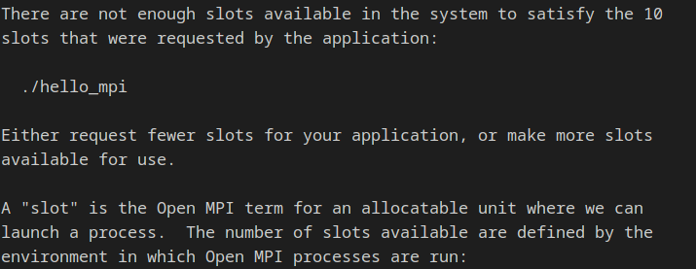

**Problem Statement 2:**

Implement a program to display rank and communicator group of five processes

**Screenshots:**

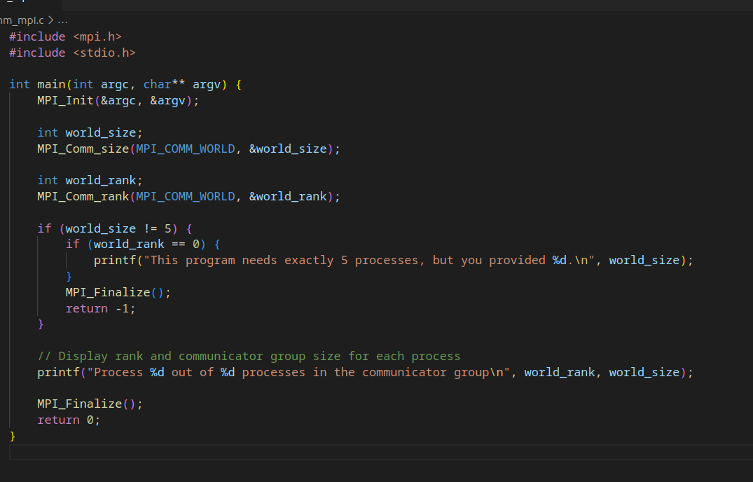

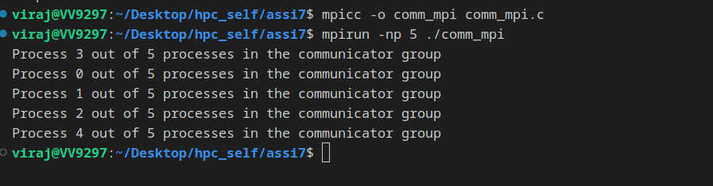

**Information:**

A communicator group is a group of processes that communicate with each other currently there is only one communicator group with 5 processses